
College of Engineering

Mechatronics Engineering Program
Final Year Project-1 Progress Report

Course Code: MCTE5193

Project Code:
Project title:
Student Information
 | Name: | I.D. No.: | Telephone:
Team Leader:
Team Members:

Signatures: Date: ___ / ___ / ____

_________________ ___________________ ___________________
Student Team Leader Advisor(s) FYP Coordinator

Table of Contents

List of Figures III
List of Tables IV
Chapter 1: Introduction 1
1.1 Background 1
1.2 Problem Statement 1
1.3 Project Objectives 1
1.4 Expected Benefits 1
1.5 Motivation 1
1.6 Impact of the Project 1
1.7 Project Outline 1
Chapter 2: Literature Review 2
Conclusion 4

List of Figures

Figure 1.1 Sample of project outline 1

List of Tables

Chapter 1: Introduction

1.1 Background
The necessary background for someone working in the general area of your work to understand. It should not include what is considered a general knowledge in the area. You may have subsections in this section (1.1.1, 1.1.2, .. etc).

1.2 Problem Statement

1.3 Project Objectives

1.4 Expected Benefits

1.5 Motivation

1.6 Impact of the Project

1.7 Project Outline

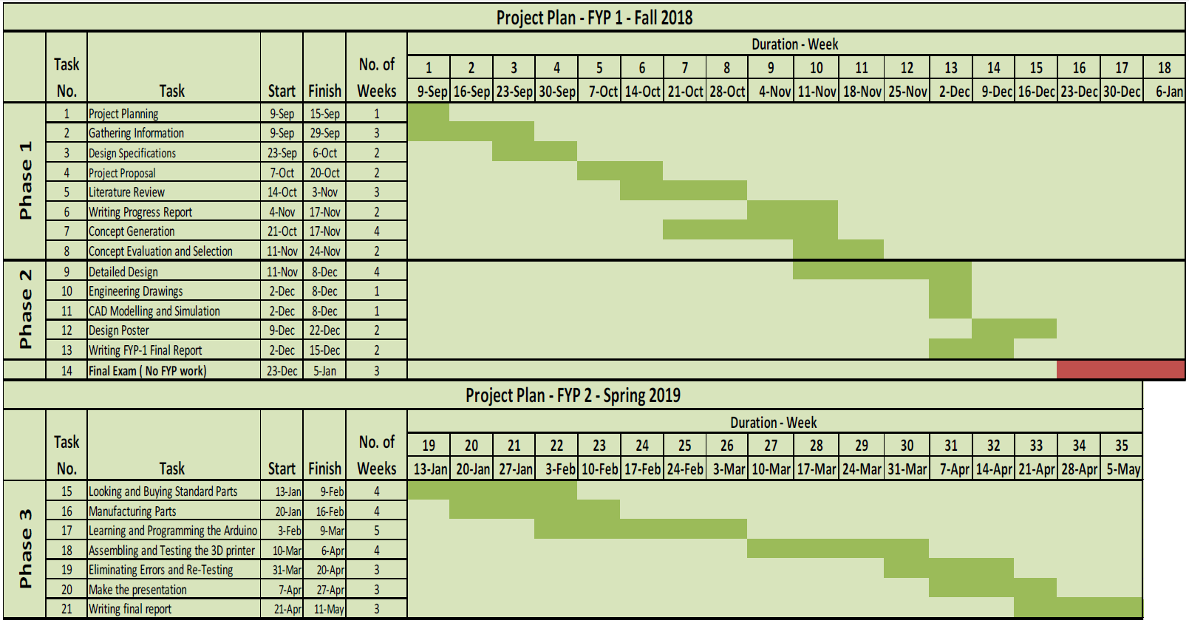

Figure 1.1 Sample of project outline

Chapter 2: Literature Review

A literature review is a search and evaluation of the available literature in your given subject or chosen topic area. It documents the state of the art with respect to the subject or topic you are writing about. The subsections and topics in this chapter should be agreed with the supervisor. You can use software like EndNote or Mendeley to help you organizing the references.

The main tasks of literature review are:

- Demonstrates a familiarity with a body of knowledge and establishes the credibility of your work;
- Summarizes prior research and says how your project is linked to it;
- Integrates and summarizes what is known about a subject;
- Demonstrates that you have learnt from others and that your research is a starting point for new ideas.

Example:

“Functionally graded materials are advantageous over conventional composite materials by having a continuous microstructure and gradual change of properties. This continuity eliminates problems like stress jumps and delamination which are major issues with conventional composite materials. In addition to preserving the advantage of continuous microstructure and gradual change of properties that FG materials offer, FG porous structures offer a significant weight reduction as compared to fully porous structures, and reasonable strength as compared to the precursor foaming material [1, 2]. Functionally graded aluminum foam with linear decreasing density gradient was found to possess excellent performance in energy absorption [3]. A range of linear PVC, crosslinked PVC and PEI foams bonded together to produce a three layer core were fabricated by Zhou and co-authors [4]. It was concluded that the graded structures out-perform a single type foam structure. One important result from their work suggested placing the high density foam core against the top surface skin for an improved perforation resistance. There are many other studies which all support the claim that FG porous structures lead to high strength-to-weight ratio materials.”

References

[1] F. Al Jahwari, A. A. W. Anwer, and H. E. Naguib, "Fabrication and microstructural characterization of functionally graded porous acrylonitrile butadiene styrene and the effect of cellular morphology on creep behavior," Journal of Polymer Science Part B: Polymer Physics, vol. 53, pp. 795-803, 2015.
[2] F. A. Jahwari and H. E. Naguib, "Linear viscoelastic modeling and validation of functionally graded heterogeneous porous PLA structures with a C1-continuous plate theory and novel homogenization," presented at the Foams, New Jersey, USA, 2014.
[3] X. Zhang and H. Zhang, "Optimal design of functionally graded foam material under impact loading," International Journal of Mechanical Sciences, vol. 68, pp. 199-211, 2013.
[4] J. Zhou, Z. W. Guan, and W. J. Cantwell, "The impact response of graded foam sandwich structures," Composite Structures, vol. 97, pp. 370-377, 2013.

